**Challenge Overview**

In this challenge, we will use HTMl and CSS to create complicated shapes and effects on a webpage.

**Technical Requirements**

1. Create four squares in square with a border (when you hover over an inner square invert that squares background and border color).

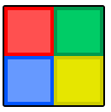

1. Animate a square to move side to side and change its color.

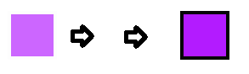

1. Create a Jack o’ Lantern and/or a flower

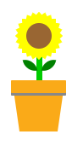

**Final Submission Guidelines**

Download code, Zip into folder, and Email to mstimpson@eaglecrk.com